Chapter 4 Assignments
1. Consider a datagram network using 32-bit host addresses. Suppose a router has four links, numbered 0 through 3, and packets are to be forwarded to the link interfaces as follows:
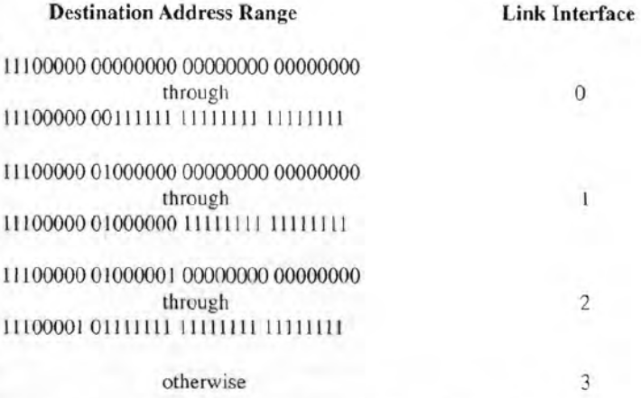
- Provide a forwarding table that has four entries, uses longest prefix matching, and forwards packets to the correct link interfaces.
- Rewrite this forwarding table using the a.b.c.d/x notation instead of the binary string notation.
- Describe how your forwarding table determines the appropriate link interface for datagrams with destination addresses:
11001000 10010001 01010001 01010101
11100001 01000000 11000011 00111100
11100001 10000000 00010001 01110111
Solution:
a)
Destination Prefix Link Interface
11100000 00 0
11100000 01000000 1
1110000 2
11100001 1 3
otherwise 3

b)
Destination Prefix Link Interface
11100000 00 (224.0/10) 0
11100000 01000000 (224.64/16) 1
1110000 (224/7) 2
11100001 1 (225.128/9) 3
otherwise 3

c)
Destination Link Interface
11001000 10010001 01010001 01010101 3 (matching 5th entry)
11100001 01000000 11000011 00111100 2 (matching 3rd entry)
11100001 10000000 00010001 01110111 3 (matching 4th entry)

2. Consider the topology shown below.
- Assign network addresses to each of these six subnets, with the following constraints: All addresses must be allocated from 214.97.254/23; Subnet A should have enough addresses to support 250 interfaces; Subnet B should have enough addresses to support 120 interfaces; and Subnet C should have enough addresses to support 120 interfaces. Of course, subnets D, E and F should each be able to support two interfaces. For each subnet, the assignment should take the form a.b .c.d/x or a. b. c .d/x – e. f. g. h/y.
- Using your answer to part (A), provide the forwarding tables (using longest prefix matching) for each of the three routers.
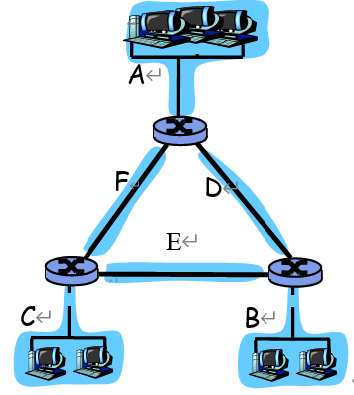
Solution:
From 214.97.254/23, possible assignments are
a) Subnet A: 214.97.255/24 (256 addresses)
Subnet B: 214.97.254.0/25 - 214.97.254.0/29 (128-8 = 120 addresses)
Subnet C: 214.97.254.128/25 (128 addresses)

Subnet D: 214.97.254.0/31 (2 addresses)
Subnet E: 214.97.254.2/31 (2 addresses)
Subnet F: 214.97.254.4/30 (4 addresses)

b) To simplify the solution, assume that no datagrams have router interfaces as ultimate destinations. Also, label D, E, F for the upper-right, bottom, and upper-left interior subnets, respectively.

Router 1

Longest Prefix Match Outgoing Interface

11010110 01100001 11111111 Subnet A
11010110 01100001 11111110 0000000 Subnet D
11010110 01100001 11111110 000001 Subnet F
Router 2

Longest Prefix Match Outgoing Interface

11010110 01100001 11111111 0000000 Subnet D
11010110 01100001 11111110 0 Subnet B
11010110 01100001 11111110 0000001 Subnet E

Router 3

Longest Prefix Match Outgoing Interface

11010110 01100001 11111111 000001 Subnet F
11010110 01100001 11111110 0000001 Subnet E
11010110 01100001 11111110 1 Subnet C

3. Consider the network shown below, and assume that each node initially knows the costs to each of its neighbors. Consider the distance-vector algorithm and show the distance table entries at node z.
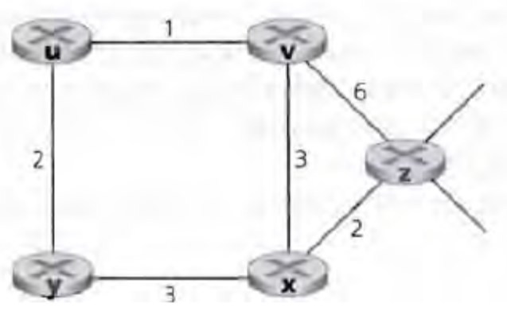
Solution:
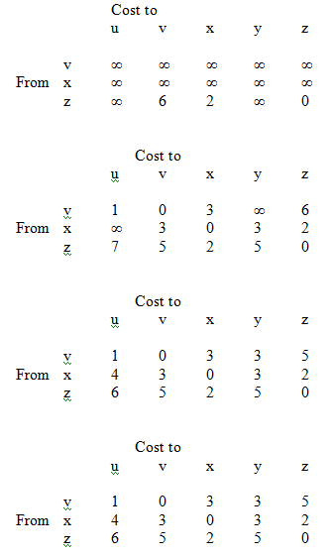

4. Please compare LSR and DVR, and explain each suitable usage scenarios. How Internet routing protocols deal with DVR count-to-infinity problem?
Solution:
LSR and DVR are two main routing algorithms widely used practically. We can’t say which one is better, both have its own advantages and disadvantages. The comparison is based on the following 4 facets:
- message complexity: how many msgs sent between all n nodes?
- LS: with n nodes, E links, totally O(nE) msgs sent
- DV: exchange between neighbors only, totally O(n) msgs sent
- computation complexity: algorithm for calculating least cost each
- LS: each node calculate using Dijkstra , O(n²)
- DV: each node calculate the least cost to (n-1) nodes using Bellman-Ford equation , O(n)
- speed of convergence: given a change, how long until the network re-stabilizes?
- LS: 1 iteration. may have oscillations
- DV: n iterations. good news travel fast, but possible count-to-infinity problem for bad news.
- Robustness: what can happen if a router fails or misbehaves?
- LS: robust. Node route calculations are somewhat separated
- DV: an incorrect node calculation can be diffused through the entire network. A node can advertise incorrect least-cost paths to its neighbors and then pass indirectly to its neighbor’s neighbors and then to all destinations.
According the above analysis, LSR variants are suitable for small networks, and DVR variants are suitable for relatively large networks. Both are widely used in Internet. For example:
Intra-AS routing protocols:
- RIP: DVR based. The distance metric is # of hops, limits networks to 15 hops (16 =∞ to avoid count-to-infinity)
- OSPF: LSR based. Hierarchical OSPF for large networks.
Inter-AS routing protocols:
- BGP: DVR based. DVR with explicit AS path avoid count-to-infinity

5. What’s the difference between Intra-AS Routing and Inter-AS Routing?
Solution: Intra-AS and Inter-AS routing differ in the following 2 facets:
policy:
- Inter-AS: admin wants control over how its traffic routed, and who routes through its net. (untrusted)
- Intra-AS: single admin, so no policy decisions needed (trusted)
performance:
- Intra-AS: can focus on performance
- Inter-AS: policy may dominate over performance
6. Please explain methods to reduce the size of routing table.
Solution:
Methods to reduce the size of routing table include but not limited to:
- Using network prefix instead of the whole destination IP address.
- Using CIDR technology to converge multiple continuous IP prefix into one.
- Using hierarchical routing to reduce destination prefix.

7. Please explain why we need IPv6 to replace IPv4.
Solution:
The reasons for replacing IPv4 with IPv6 include but not limited to:
- To provide more IP addresses, IPv6 have larger IP address space.
- To simplify the IP header and speed up the routing processing.
- To support more features, including QoS, IP security etc.
8. Company A needs 1024 IP addresses from an ISP who owns network prefix 206.0.64.0/18. Company A has 4 departments: Department1 requires 510 addresses which is further divided into 4 LANs(LAN1~LAN4); Department2 requires 256 addresses which is further divided into 4 LANs(LAN5~LAN8); Department3 requires 128 addresses which is further divided into 2 LANs(LAN9~LAN10); Department4 requires 128 addresses which is further divided into 2 LANs(LAN11~LAN12) . Another subnet LAN0 only needs 1 public IP address which uses NAT. please assign IP prefix to these 13 subnets with CIDR (Classless Inter-Domain Routing) technology. Please fill in the routing tables for RA, R1 and R3. Please aggregate entries if possible
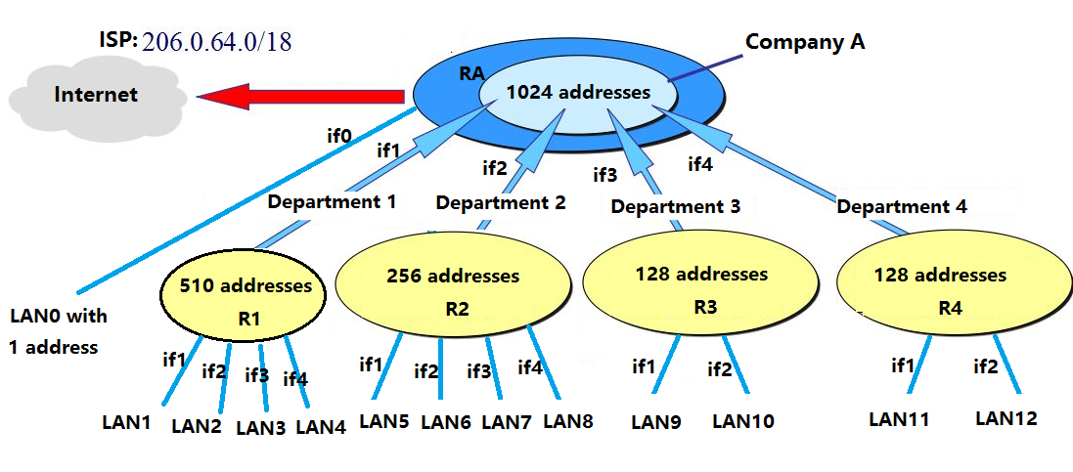
Note注意: 此题答案非唯一。下面只是其中一种可能，以206.0.68、72、76…124都是正确的。The above table isn’t the only one solution. Other options could start from 68、72、76…124 instead of 64 for the third 8-bit in the four 8-bit IPv4 address.
network | network prefix | network mask | network | network prefix | network mask
LAN0 | 206.0.64.0 | 255.255.255.255 | LAN7 | 206.0.66.128 | 255.255.255.192
LAN1 | 206.0.64.0 | 255.255.255.128 | LAN8 | 206.0.66.192 | 255.255.255.192
LAN2 | 206.0.64.128 | 255.255.255.128 | LAN9 | 206.0.67.0 | 255.255.255.192
LAN3 | 206.0.65.0 | 255.255.255.128 | LAN10 | 206.0.67.64 | 255.255.255.192
LAN4 | 206.0.65.128 | 255.255.255.128 | LAN11 | 206.0.67.128 | 255.255.255.192
LAN5 | 206.0.66.0 | 255.255.255.192 | LAN12 | 206.0.67.192 | 255.255.255.192
LAN6 | 206.0.66.64 | 255.255.255.192

R1 |  |  |  | RA
Prefix | Mask | Interface |  | Prefix | Mask | Interface
206.0.64.0 | 255.255.255.128 | 1 |  | 206.0.64.0 | 255.255.255.255 | 0
206.0.64.128 | 255.255.255.128 | 2 |  | 206.0.64.0 | 255.255.254.0 | 1
206.0.65.0 | 255.255.255.128 | 3 |  | 206.0.66.0 | 255.255.255.0 | 2
206.0.65.128 | 255.255.255.128 | 4 |  | 206.0.67.0 | 255.255.255.128 | 3
R3 |  |  |  | 206.0.67.128 | 255.255.255.128 | 4
206.0.67.0 | 255.255.255.192 | 1
206.0.67.64 | 255.255.255.192 | 2

